FIRST TERMINAL EXAMINATION – SEPTEMBER2019
MATHEMATICS

Class: IV Max Marks:60
Date:23.09.19 Time: 3 hours
I. Fill in the blanks: (5 × 1= 5)
1) The place value of 9 in 329145 is _______.
2) The successor of 9999 is _______.
3) 3754 - ______= 3753 .
4) 15 x ____= 0.
5) 49 ÷ 49 =__________.
II.Choose the correct answer: (5 × 1= 5)
6) The number 100 less than 7125 is _________.
(a) 6025 (b) 7025 (c) 7000 (d) none of these
7) 4752 rounded off to the nearest hundred is ______.
(a) 4000 (b) 4750 (c) 4700 (d) 4800
8) 4 more than a dozen is ______.
(a) 10 (b) 12 (c) 8 (d) 16
9) The product of two numbers is16.One number is 2.To find the other number
(a) divide16 by 2 (b) multiply 16 by 2 (c) divide 2 by 16 (d) none of these
10) 650-600=50. Here,650 is called the ______.
(a) difference (b) sum (c)subtrahend (d)minuend

III. Match the following: (5x1=5)
11) Pictograph (a) mirror images
12) Largest 4-digit number (b) 9909
13) Reflections (c) 9099
  - +900+9 (d) pictures
15) 1 x 9099 (e) 9999
IV. Write whether the following statements are TRUE or FALSE: (5 × 1=5 )
16) Quotient x Remainder +Divisor = Dividend
17) When 1 is added to a number,the sum is the successor of the number.
18) Symmetrical figures can be divided into two parts of equal size and shape.
19) The answer in an addition question is called difference.
20) When adding more than two numbers,the numbers can be grouped in any way.
V. Answer the following: (10 × 2= 20)
21) Write the following in ascending order:
32526,35726,37526,36527
22) Write the number names for:
a) 98642
b) 900482
23) Write the numerals for:
a) seven lakh twenty thousand nine hundred and six.
b) 30000+4000+600+70+9

24) Write the smallest and greatest number using all the given digits:
5,0,3,4,1,7
25) Round off the following
a) 6777 to the nearest 100
b) 23126 to the nearest 1000.
26) Multiply 507 and 8.
27) Find the quotient and remainder without doing long division
a) 4109 ÷ 1000
b) 235 ÷ 100
28) Draw the line of symmetry
a)

b)
29) Find the sum of 1340 and 5647
30) Find the difference between 41262 and 20140.
VI. Answer the following: (5×3= 15)
31)A box contains 537 buttons.How many buttons are there in 26 boxes?
32) Divide and check your answer
649 ÷ 3
33) The total cost of a television set and a mobile phone is Rs.55,990.If the mobile phone costs Rs.17,897,find the cost of the television set.
34) A factory manufactured 45,850 cars in 2010 and 33,975 cars in 2011.How many cars are produced totally by the factory?

35) Find the difference of the place values of 8 in 98892.
VII. Answer the following: (5×1=5)
36) The pictograph shows the number of toys sold during the days of a week from a toy shop. Give the following information regarding sale of toys.
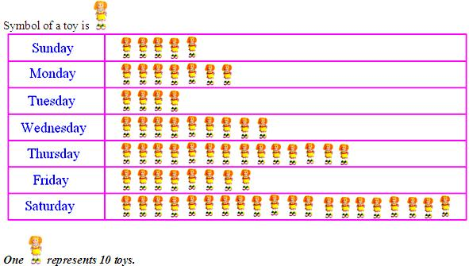

(i) Find the number of toys sold on Thursday
(ii) Find the number of toys sold during the week.
(iii) On which day were the maximum numbers of toys sold?
(iv) On which day were the minimum numbers of toys sold?
(v) What is the difference in number of toys sold on Saturday and Tuesday?

